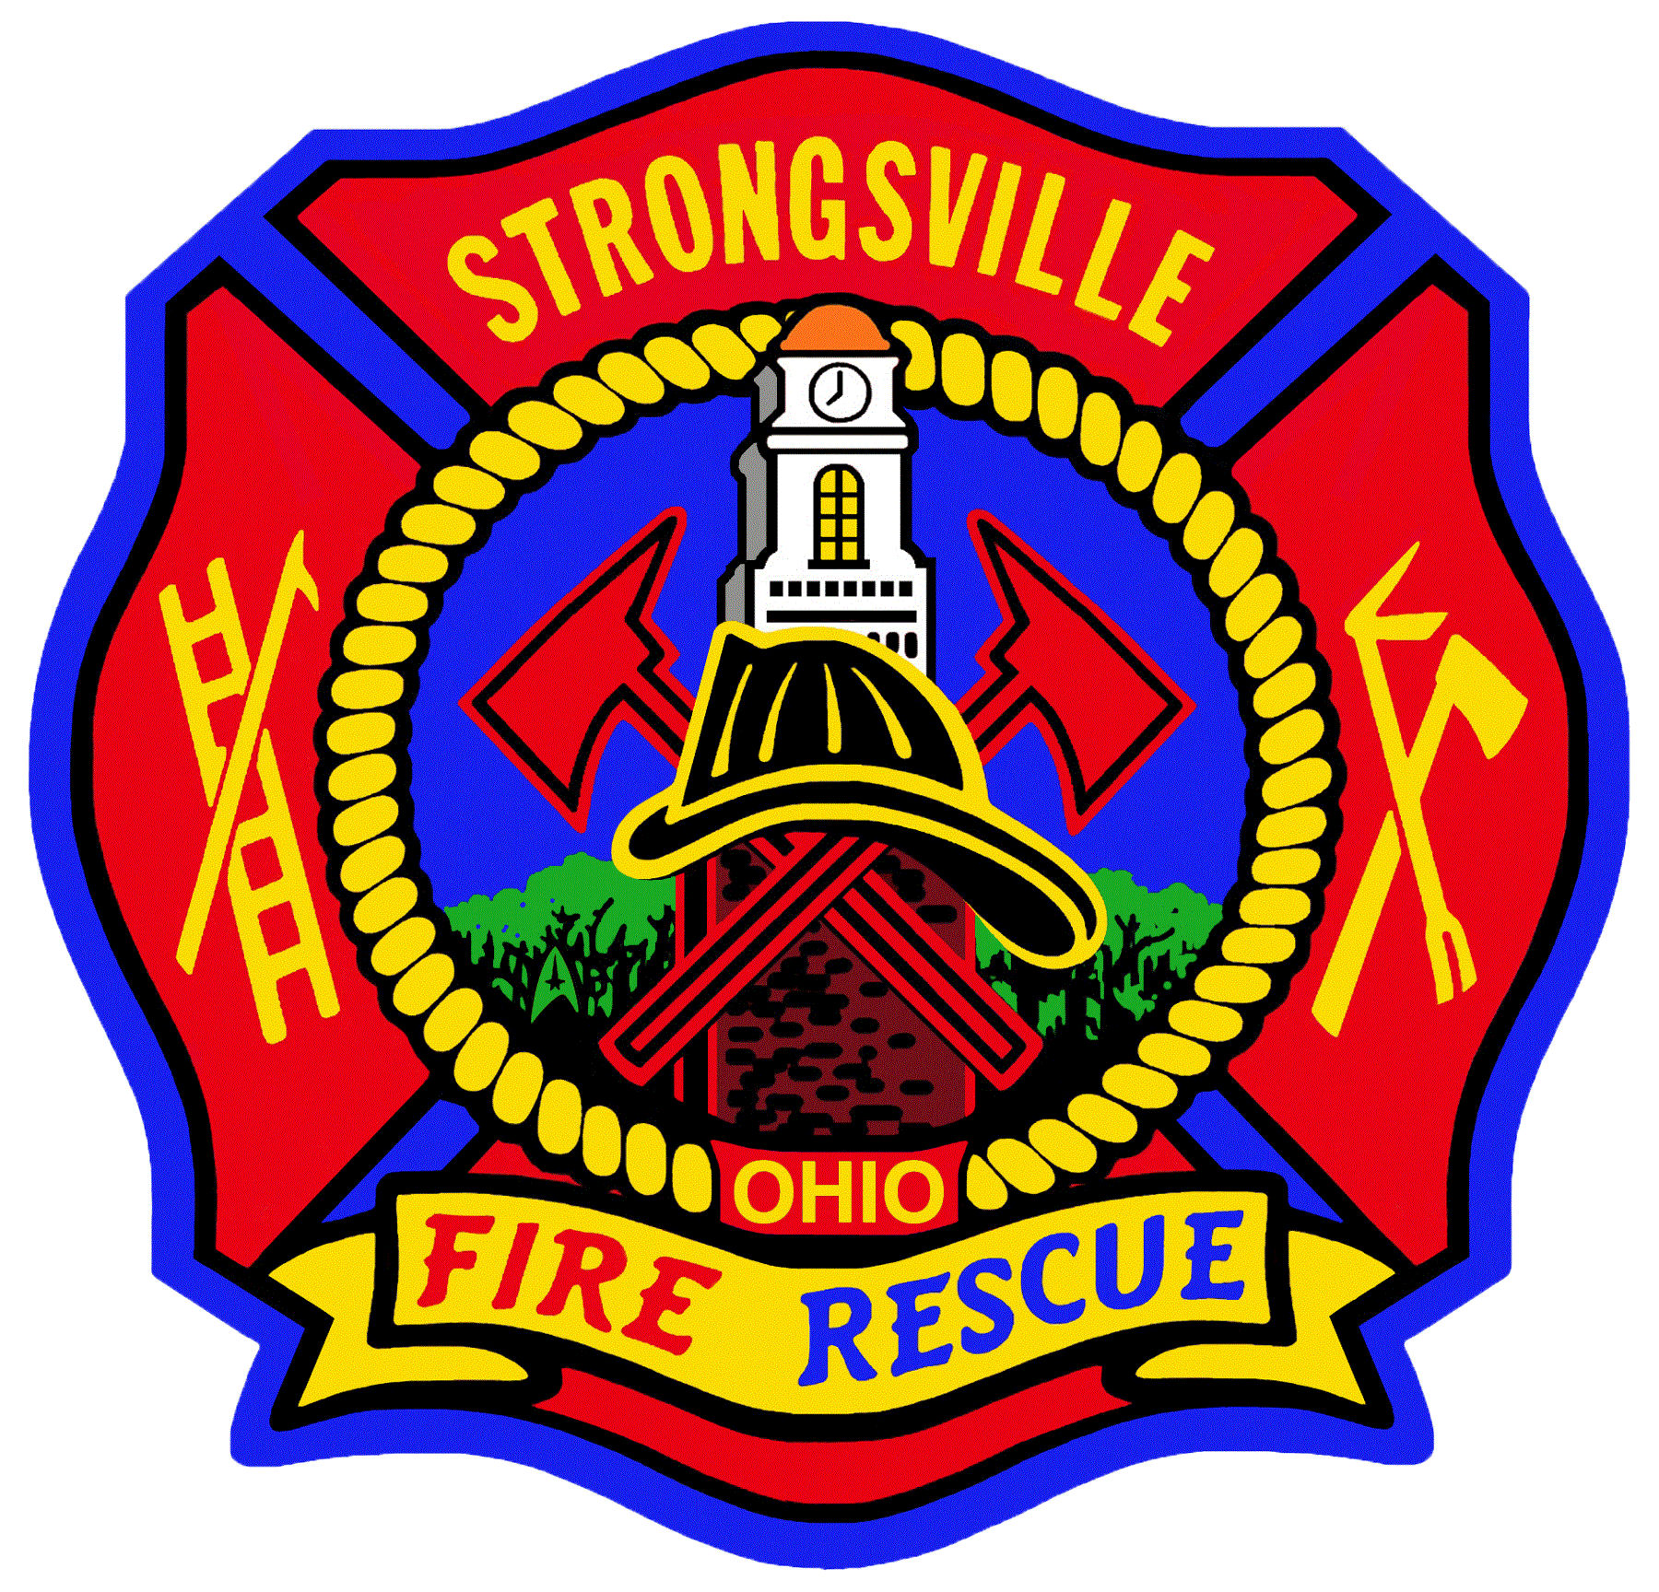**STRONGSVILLE FIRE and EMERGENCY**

**SERVICES DEPARTMENT**

**PUBLIC SERVICE ANNOUNCEMENT**

**Fireplace Safety**

**Remember Routine Maintenance**

The Strongsville Fire Department and the Chimney Safety Institute of America (CSIA) recommend that you have your chimney and fireplace inspected and cleaned once a year to make sure your fireplace is clear of any potential hazards and operating efficiently.

**Install a Spark Screen**

If you’ve ever sat around a popping campfire and gotten too close to witnessing a stray spark burn straight through your pants, then you’ll understand the importance of having a spark screen protect your home from the things your fireplace can produce. This is especially true if you enjoy decorating your mantel during the holiday season. Any flammable material nearby can spell disaster if a spark from the fireplace manages to escape.

**Keep a Safe Distance**

Keep all furniture and other flammable materials at least 3 feet from your fireplace or stove. This provides ample space for the radiant heat from the fire to dissipate, making it less likely nearby materials will catch on fire.

**Use the Right Fuel**

The only wood that should be used in your wood-burning fireplace is dry, seasoned hardwood. What that means is selecting wood that has been properly dried for an extended period of time (in most cases, at least 6 months). Seasoned hardwood burns more efficiently, producing less smoke and creosote buildup in your chimney. This should go without saying, but under no circumstances, should you use flammable liquids to start or accelerate the fire.

**Supervise Children & Pets**

Always keep a close eye on children and pets when the fireplace is in use. If need be, consider using safety gates or barriers to keep curious children and pets a safe distance from the fire. For older children, establish clear boundaries and reiterate the importance of responsible behavior around any flames.

**Never Leave a Fire Unattended**

Whether you’re calling it a night or simply just stepping away briefly, it’s extremely important to never leave a fire going unattended. Even a seemingly well-contained fire can spit out a loose ember or spark, potentially igniting nearby materials. It can happen faster than you think!

**Dispose of Ashes Safely**

Ash that is over an inch thick at the bottom of the fireplace can restrict air flow to the logs, thus producing more smoke (and, by consequence, more creosote). To maintain optimal airflow and prevent other potential issues from arising, dispose of cool ashes in a metal container with a tight fitting lid. These ashes should be stored outside, away from any combustible materials and at least 10 feet away from your home or any nearby buildings. Wait a few days before disposing of them properly.

**Check Smoke & Carbon Monoxide Detectors**

The smoke detectors and carbon monoxide detectors in your home should be tested at least once a month and have the batteries replaced every six months. That way, if there were an emergency, you’d be alerted quickly.

**Keep Fire Extinguisher Nearby**

Another way to be prepared in the event of fire is to always keep a fire extinguisher within easy reach of your fireplace. Choose an extinguisher that is rated for wood or paper fires (Class A) and familiarize yourself with how to use it properly. Having a fire extinguisher nearby helps provide a quick way to eliminate a small fire before it has a chance to escalate.

**Plan & Practice Emergency Preparedness**

We hope you never experience an event in which you have to carry out your emergency preparedness plan. However, if you have multiple people living in your house, it’s always a good idea to plan and practice how to respond in case a fire-related emergency arises. Establish clear evacuation routes, a designated meeting point, and practice these drills periodically.